**A Project Report on**

“Digital Stopwatch”

**Prepared By**

“Jayshil Patel”

(18EC068)

**Under Guidance of**

Prof. Rajat Pandey and Prof. Yogesh Tiwari

**Submitted to**

Charotar University of Science & Technology for Partial Fulfilment of the Requirements for the Degree of

Bachelor of Technology

In Electronics and Communication

EC-244-Mini Project-I

Of 3rd Semester of B.Tech

Submitted At



**V.T Patel Department of Electronics and Communication**

Faculty of Technology & Engineering, CHARUSAT

Chandubhai S. Patel Institute of Technology

At Changa, Dist: Anand-388421

**CERTIFRICATE**

This is to certify that the report entitled “**Digital Stopwatch”** is a bonafide work carried out by Jayshil Patel under the guidance and supervision of **Prof. Rajat Pandey** and **Prof. Yogesh Tiwari** for the subject **Mini Project-I(EC244)** of 3rd Semester of Bachelor of Technology in Electronics and Communications at Faculty of Technology and Engineering ( CSPIT) – CHARUSAT, GUJARAT.

To the best of knowledge and belief, this work embodies the work of candidate himself, has duty being completed, and fulfils the requirement of the ordinance relating to the subject specified for 3rd semester of the University and is up to the standard in respect of content, presentation and language for being referred to the examiner.

Under the supervision of,

Prof.Rajat Pandey Prof.Yogesh Tiwari

Assistant Professor Assistant Professor

Department of Electronics & Department of Electronics & Communication Communication

CSPIT, CHARUSAT Changa. CSPIT, CHARUSAT Changa.

Dr.Trushit K. Upadhyaya

Head of Department,

Department of Electronics & Communication

CSPIT, CHARUSAT - Changa, Gujarat.

**ChandubhaiS Patel Institute of Technology ( C.S.P.I.T)**

**Faculty of technology & Engineering, CHARUSAT**

At: Changa, Ta. Petlad, Dist. Anand, Gujarat – 388421

**Acknowledgement**

I take this opportunity to express my profound gratitude and deep regards to my guide Prof. Rajat Pandey & Prof. Yogesh Tiwari and HOD of E & C department of CSPIT, Prof. Trushit Upadhyaya, for their exemplary guidance, monitoring, and constant encouragement throughout the course of this project. The blessing, help and guidance given by them time to time shall carry me a long way in the journey of life on which I am about to embark.

Jayshil Patel ( 18EC068)

CSPIT, CHARUSAT.

**TABLE OF CONTENTS**

**Chapter 1: introduction of project........................................................................................5**

1.1. Problem..................................................................................................................5

1.2 Solution...................................................................................................................5

1.3 overview..................................................................................................................5

1.4 circuit diagram........................................................................................................6

**Chapter 2: Project Description (hardware).........................................................................7**

2.1 Block diagram........................................................................................................7

**Chapter 3: Components and its Details................................................................................8**

3.1 list of Components and details...............................................................................8

**Chapter 4: Implementation...................................................................................................11**

4.1 Hardware implementation......................................................................................11

4.2 PCB Design in software........................................................................................12

**Chapter 5: Applications and Future scope.........................................................................14**

5.1 Applications..........................................................................................................14

5.2 Pros & Cons..........................................................................................................15

**Conclusion.............................................................................................................................16**

**Reference...............................................................................................................................17**

**CHAPTER 1 – INTRODUCTION OF PROJECT**

Often we need a stopwatch to differentiate the time of two events; here is a stopwatch designed with a simple circuit and without using any microcontroller.

**1.1 Problem**

Doubtlessly analog stopwatch have helped us in many ways but since to record an exact time of interval with precision it needs higher accuracy and focus to read analog whereas in digital stopwatch once the switch is released we exact reading on the display.

**1.2 Solution**

A simple digital clock which holds up on the reading, once recorded until it is put to reset, using timer and counter IC to regenerate and count the clock pulse, a decoder to convert the recorded number to user friendly readable 7 segment display.

**1.3 Overview**

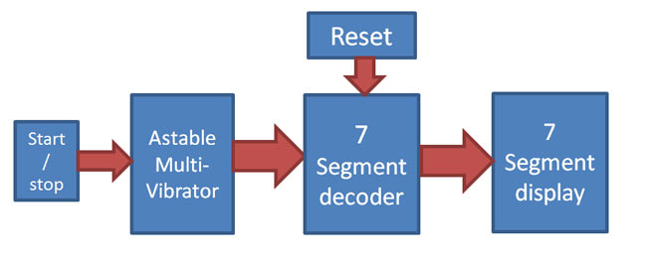(Fig1)showing the block diagram of the circuit

Figure 1 shows the overview of the project. The start and stop button will allow the clock pulse from 555 timer to the counter IC then the counter IC will count and decode it and feed it into the 7 segment output. For 2 digits we use cascading of two counter ICs. The reset button will inhibit the counter’s clock back to initial value which will overall result in resetting of whole counter.

**1.4 Circuit diagram**

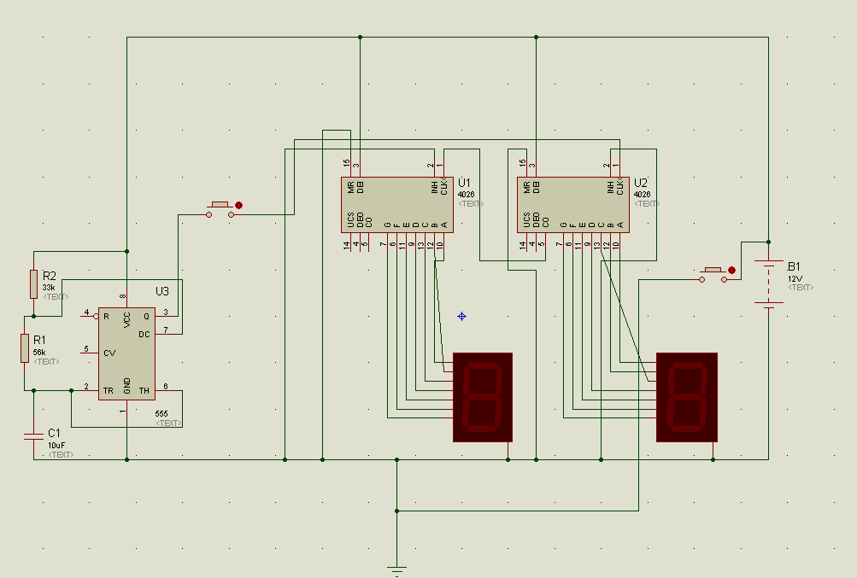(Fig2)circuit implementation in proteus software

Figure 2 shows the complete circuit of stopwatch showing the connection of 555timer with cascading of 4026 and displaying the output on 7 segment.

**CHAPTER 2 – PROJECTDESCRIPTION (HARDWARE)**

**2.1Block Diagram**



(Fig3)showing block diagram of flow of circuit

Figure 3 shows the complete flow of the digital stopwatch

Here the 555 timer is set into astable mode which will generate clock pulse of one second time period or one Hz frequency, the pulse generated must be counted hence we require a counter, after counting the desired output is expected on 7-segment display, hence we also require a decoder to convert the number to 7 segment code, hence we use 4026 or 4033 which have counter and decoder in one package.

The reset pin available in 4026 sets the IC to the initial value, hence by resetting the counter.

**CHAPTER 3-COMPONENTS AND ITS DETAILS**

**3.1 Components and details**

**1) NE555 timer IC**

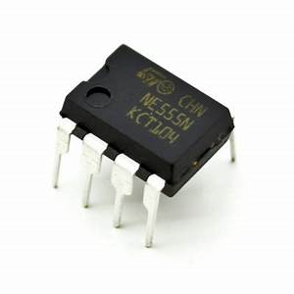

(fig4)ne555 timer IC outer view

The figure shows 555 timer IC is a highly stable controller capable of producing accurate timing pulses. With an astable operation, the frequency and duty cycle are accurately controlled by two external resistors and one capacitor,

We can implement it by using equation

T(high+low) = 0.693 x (R1 x 2R2) x C1

The connections can be done as in figure 5

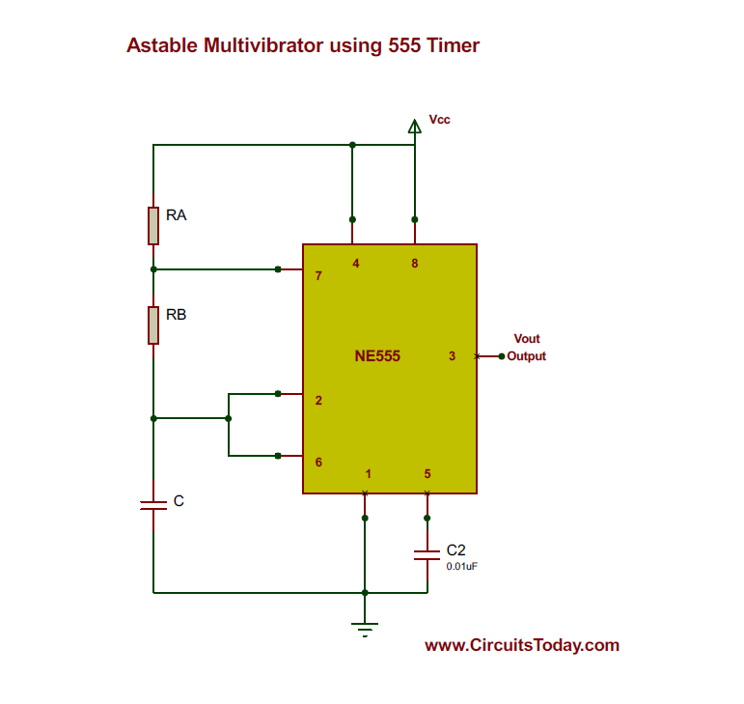

(fig5)showing connections of 555 timer IC in Astable mode

**2) CD4026BE**

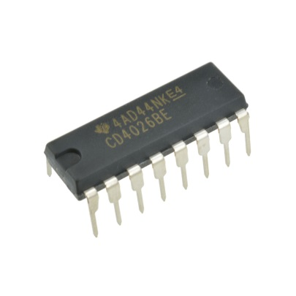

(fig6)showing outer view of 4026 IC

IC 4026 is counter and 7-segment decoder in one package, it’s easily interfaced with 7-segment display,

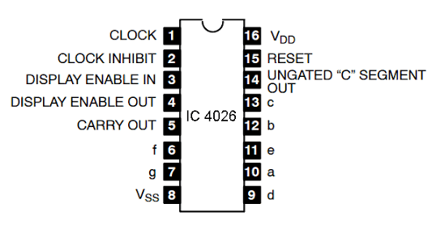

(fig7)showing pin diagram of 4026 IC

Here from the pin diagram;

We get display enable in and out for both 7 segment cathode and anode, clock input for the counter to counter the pulses, clock inhibit to enable the counter as positive or negative edge triggering, whenever the 2nd pins is set into high or low respectively, then we have 7 output for our seven segment display, we get a pulse from 5 pin (carryout) on every one cycle of the counter i.e., from 0-9, reset pin is available to reset the counter to its initial value.

**3) 7- segment cathode**

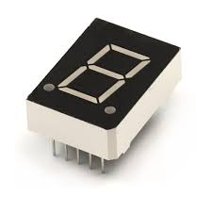

(fig8) showing outer view of 7 segment

Seven segment cathodes displays the respective segment if the segment is set on high and the common pin is grounded; hence we can have all desired number with specific formulas and equation to decode the number to seven segment input

**CHAPTER-4 IMPLEMENTATION**

**4.1 Hardware implementation**

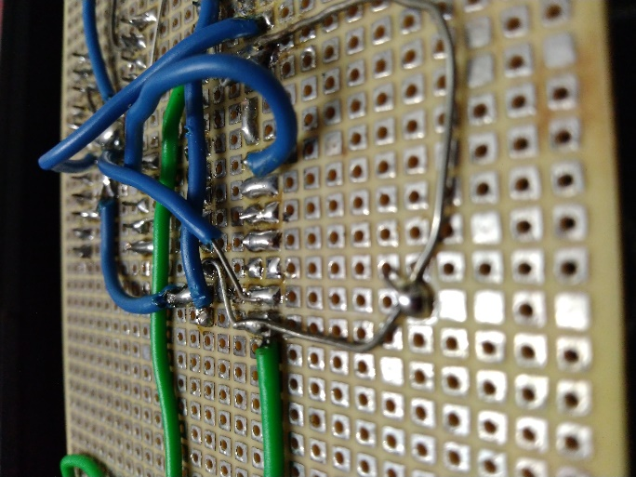

(fig9)showing soldered components on board

The figure shows the over view of soldered components upon general purpose board,

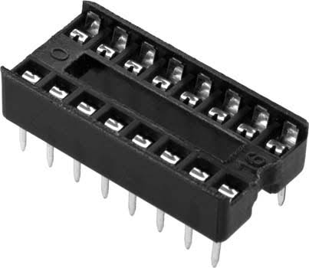

(fig10)showing IC holder

We use IC holders, because when we solder the IC, due to excess heating of its legs may damage the internal circuit of the IC which may after all result in circuit failure

Isolation of soldered nodes is must; we must ensure that we have precisely soldered the points, if there is single error in soldering it will result in cascade of circuit failures, and hence de-soldering is the only way

**4.2 PCB designing in software**

To design the PCB in software, I have used Proteus software, after completing the schematic and ensuring the connections after its stimulation we load the netlist into ARES software,

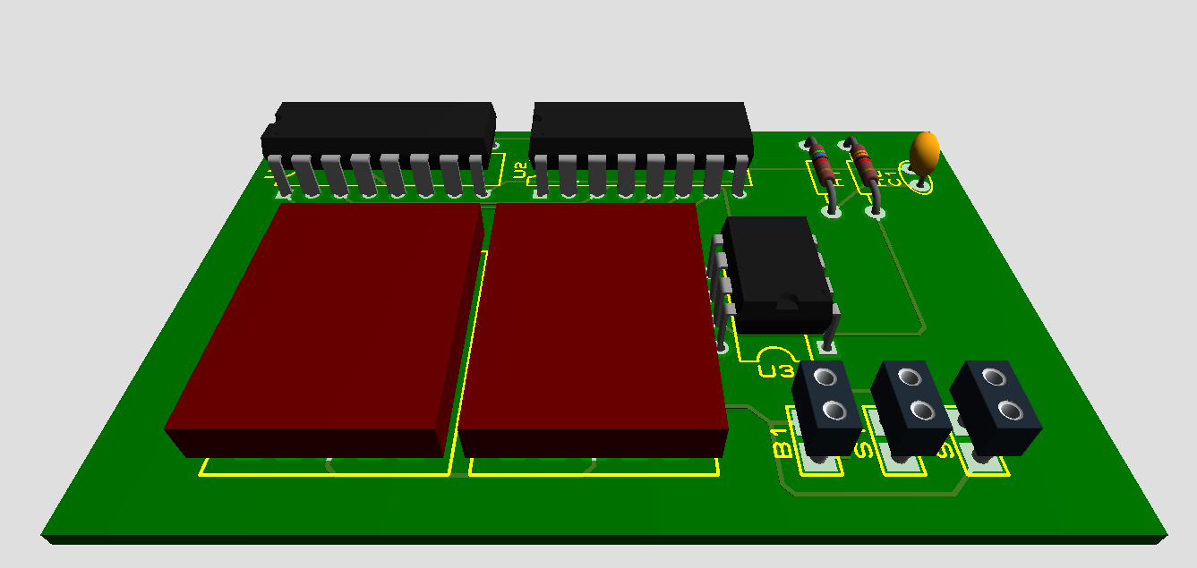

(fig12)showing 3d output

After placing and routing we end up with an ARES file which will help us in making Gerber files

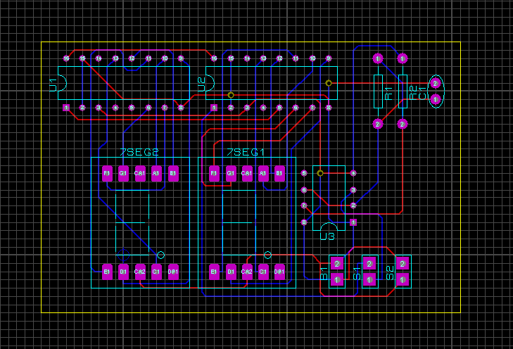

(fig13)showing routing image

**CHAPTER-5 APPLICATIONS AND FUTURE SCOPE**

**5.1 Applications**

A **stopwatch** is a handheld [timepiece](https://en.wikipedia.org/wiki/Timepiece) designed to measure the amount of time that elapses between its activation and deactivation. A large digital version of a stopwatch designed for viewing at a distance, as in a sports stadium, is called a **stopclock**. In manual timing, the clock is started and stopped by a person pressing a button. In [fully automatic time](https://en.wikipedia.org/wiki/Fully_automatic_time), both starting and stopping are triggered automatically.

[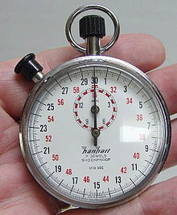](https://en.wikipedia.org/wiki/File:Stopwatch2.jpg)

(Fig14)A typical mechanical analog stopwatch

The timing functions are traditionally controlled by two buttons on the case. Pressing the top button starts the timer running, and pressing the button a second time stops it, leaving the elapsed time displayed. A press of the second button then resets the stopwatch to zero. The second button is also used to record split times or lap times. When the split time button is pressed while the watch is running, the display freezes then starts then freezes again, allowing the elapsed time to that point to be read, but the watch mechanism continues running to record total elapsed time. Pressing the split button a second time allows the watch to resume display of total time.

Mechanical stopwatches are powered by a [mainspring](https://en.wikipedia.org/wiki/Mainspring), which must be periodically wound up by turning the knurled knob at the top of the watch.

Digital electronic stopwatches are available which, due to their [crystal oscillator](https://en.wikipedia.org/wiki/Crystal_oscillator) timing element, are much more accurate than mechanical timepieces. Because they contain a [microchip](https://en.wikipedia.org/wiki/Integrated_circuit), they often include date and time-of-day functions as well. The device is used when time periods must be measured precisely and with a minimum of complications. Laboratory experiments and [sporting events](https://en.wikipedia.org/wiki/Sporting_event) like [sprints](https://en.wikipedia.org/wiki/Sprint_(running)) are good examples.

The stopwatch function is also present as an additional function of many electronic devices such as wristwatches, cell phones, portable music players, and computers.

**5.2 Pros & Cons**

PROS:-

* Clear readable output
* Accurate and single reading
* Not confused reading like analog watches
* Can be altered between minutes and milliseconds

CONS:-

* Seven segment can be broken easily
* Can measure up to only 99 seconds at current setup
* Unlike analog the 7 segment uses much higher voltage hence drains much battery

**CONCLUSION**

The stopwatch may be of many applications but by this design its cost may reduce its usability, we can limit the cost but without proper IC there can be circuit failure, and since stopwatch is all about promising the precision to user we cannot compromise with the quality. Since it can measure upto 99 seconds its applications gets widely reduced, since we can alter the frequency simply by altering the resistance values and capacitor values, rather altering all of them we can simply put a variable resistor or a potentiometer in place of any of the resistor, and with alteration of magnitude of that resistor we can set the stopwatch toread milliseconds, minutes, hours, days, or simply seconds. Digital electronic stopwatches are available which, due to their [crystal oscillator](https://en.wikipedia.org/wiki/Crystal_oscillator) timing element, are much more accurate than mechanical timepieces. Because they contain a [microchip](https://en.wikipedia.org/wiki/Integrated_circuit), they often include date and time-of-day functions as well. The device is used when time periods must be measured precisely and with a minimum of complications. Laboratory experiments and [sporting events](https://en.wikipedia.org/wiki/Sporting_event) like [sprints](https://en.wikipedia.org/wiki/Sprint_(running)) are good examples.

The stopwatch function is also present as an additional function of many electronic devices such as wristwatches, cell phones, portable music players, and computers.

**REFERENCE LINKS**

* [www.circuitdigest.com/shot_clock](http://www.circuitdigest.com/shot_clock) for how to use 4026 as counter and 7 segment decoder
* [www.circuitdigest.com/555timer](http://www.circuitdigest.com/555timer) for working of 555timer in astable mode.
* [www.wikipedia.com/digitalstopwatch](http://www.wikipedia.com/digitalstopwatch) for application, scope, and market value of stopwatches